

**Registration**

**2025 Annual Educational Symposium & Vendor Exhibition**

**Thriving in An Evolving Healthcare Landscape through Leadership and Wellness Engagement**

**Friday, June 6, 2025 8:00 AM - 4:15 PM**

**Sheraton LaGuardia East Hotel**

**135-20 39th Ave., Flushing, NY 11354**

**6.0 CEU requested for RDN’s & CDM’s**

**Name: _________________________________________________**

**Facility: ________________________________________________**

**Phone Number: _________________________________________**

**Email: __________________________________________________**

**Price including Breakfast & Lunch:**

**Facility Operator/Retired Member: $65 each (after 5/30 $85)**

**Non-Member or Guest: $125 each, including 2025 membership (eligible to attend future AHFNY events)**

**Student: $25 each (verification of full-time student enrollment required)**

**DIRECTIONS: Contact the Sheraton LaGuardia at 718-460-6666  
 Train: #7 to the last stop, Main Street**

**PARKING: Available at the underground parking lot of hotel for $15 all day. Space is limited.**

**Another parking is available at the municipal lot in front of the hotel, charges**

**25 cents per 10 minutes.**

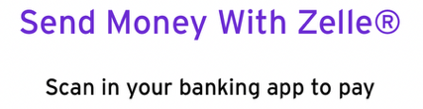**Registration online for facility operator member/retired member/non-member/guest with PayPal:** [**https://ahfny.org/events.aspx**](https://ahfny.org/events.aspx) **OR send Money with Zelle through QR code OR**

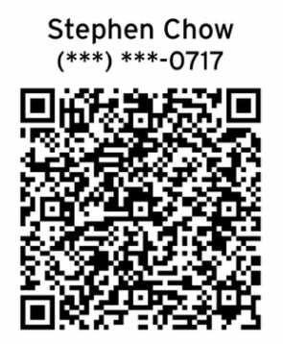**Write check to AHFNY and mail to Stephen Chow, 82 Seguine Place, S. I., NY 10312**

[**Awee012@gmail.com**](mailto:Awee012@gmail.com) **Cell: 347-466-0717 or 347-499-3956**

**All vendors please register with application form on the next page**